KPIT Project
1.Project Title and Description - Modelling and Simulation of Anti-Lock Braking System (ABS) using MATLAB/Simulink
2.Project Description
This project focuses on the development, modelling, and simulation of an Anti-Lock Braking System (ABS) using MATLAB/Simulink based Model-Based Design techniques. The primary objective of the system is to prevent wheel lock-up during sudden braking and maintain optimal wheel slip for improved vehicle stability and steering control.
The project implements a closed-loop braking control system using a PID controller to regulate brake pressure dynamically according to the wheel slip ratio. Vehicle dynamics, wheel rotational dynamics, tyre-road friction characteristics, and stopping distance estimation are mathematically modelled and simulated under varying road conditions.
The complete model was validated using Software-in-the-Loop (SIL) and Processor-in-the-Loop (PIL) testing methodologies to ensure accurate behaviour between the simulation model and generated embedded code.
This project demonstrates practical applications of:
- Automotive Control Systems
- Model-Based Development (MBD)
- Embedded System Validation
- Vehicle Dynamics & Control
- MATLAB/Simulink Simulation
3.Project Objectives –
• To design and simulate an Anti-Lock Braking System (ABS) using MATLAB/Simulink.
• To calculate and monitor wheel slip ratio in real time.
• To prevent wheel lock-up during sudden braking conditions.
• To maintain wheel slip within the optimum range for maximum traction.
• To implement a PID-based brake pressure controller.
• To estimate tyre-road friction coefficient under varying conditions.
• To analyse vehicle stopping distance for different slip ratios.
• To validate generated embedded code using SIL/PIL testing.
• To understand real-world automotive safety systems using Model-Based Design techniques.
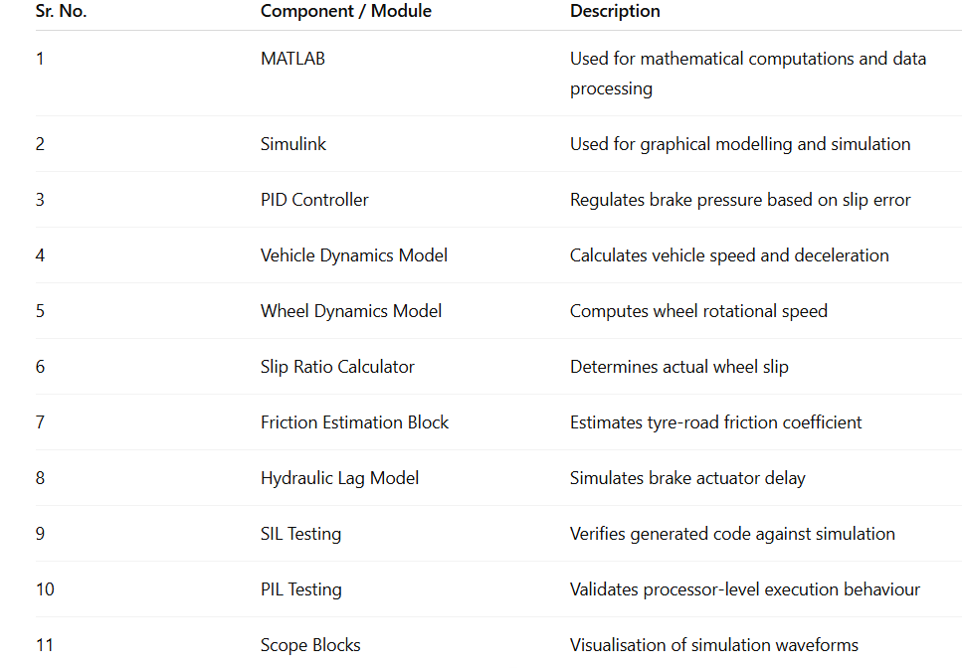
4. Components Table

5. Mathematical Modelling of the project -
The ABS model is developed using fundamental equations of vehicle longitudinal dynamics and wheel rotational dynamics.
- Vehicle Dynamics Equation
The vehicle deceleration is represented using Newton’s Second Law:
$$\frac{dV}{dt}=-μg$$
Where:
- $V$= Vehicle velocity
- $μ$= Tyre-road friction coefficient
- $g$= Acceleration due to gravity
This equation represents the reduction in vehicle speed during braking.
- Wheel Rotational Dynamics
The rotational behaviour of the wheel is represented as:
$$\frac{dω}{dt}=\frac{μm_{t}gR_{w}-T_{b}}{J_{w}}$$
Where:
$ω$= Wheel angular speed
$m_{t}$= Quarter vehicle mass
$R_{w}$= Wheel radius
$T_{b}$= Applied braking torque
$J_{w}$= Wheel moment of inertia
This equation models the effect of braking torque on wheel rotation

- Wheel Slip Ratio
The wheel slip ratio is the most important parameter in ABS control and is calculated as:
$$S=\frac{V-ωR}{V}$$
Where:
- $S$= Slip ratio
- $V$= Vehicle speed
- $ω$= Wheel angular speed
- $R$= Wheel radius
The ABS controller maintains the slip ratio near the optimal value (~0.2) to achieve maximum traction and stability.
- PID Control Logic
The PID controller continuously compares the desired slip ratio with the actual slip ratio and generates the required brake pressure command.
$$u(t)=K_{p}e(t)+K_{i}∫e(t)dt+K_{d}\frac{de(t)}{dt}$$
Where:
- $e(t)$= Slip error
- $K_{p}$, $K_{i}$, $K_{d}$= PID gains
This enables dynamic brake modulation and prevents wheel lock-up.
PID Gains Used – Kp = 30.009 , Ki = 0.0002, Kd = 0.191

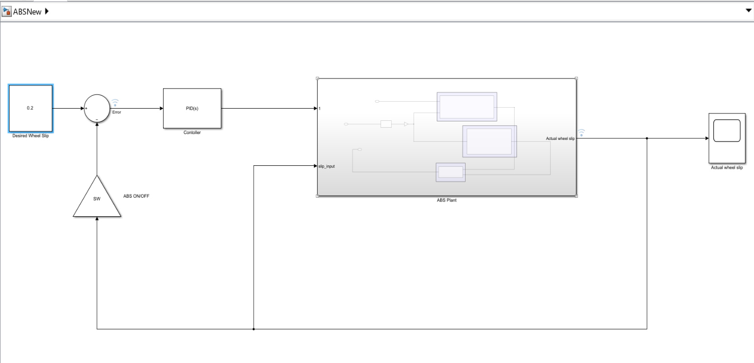
6.Simulation Model Image -

The ABS model was developed using a modular MATLAB/Simulink architecture consisting of multiple interconnected subsystems for vehicle dynamics, wheel dynamics, slip ratio calculation, brake pressure control, and stopping distance estimation.
The Vehicle Dynamics and Wheel Dynamics subsystems continuously calculate vehicle speed and wheel rotational speed during braking. These values are fed into the Slip Ratio Calculation block, which determines wheel slip in real time.
A PID Controller compares the actual slip ratio with the desired optimal slip value (~0.2) and dynamically regulates brake pressure through the hydraulic braking subsystem to prevent wheel lock-up.
Additional subsystems such as Friction Coefficient Estimation and Stopping Distance Calculation improve the realism and performance analysis of the system under different road conditions.
The complete simulation demonstrates stable braking, controlled wheel slip, improved traction, and safe vehicle deceleration using Model-Based Design techniques.

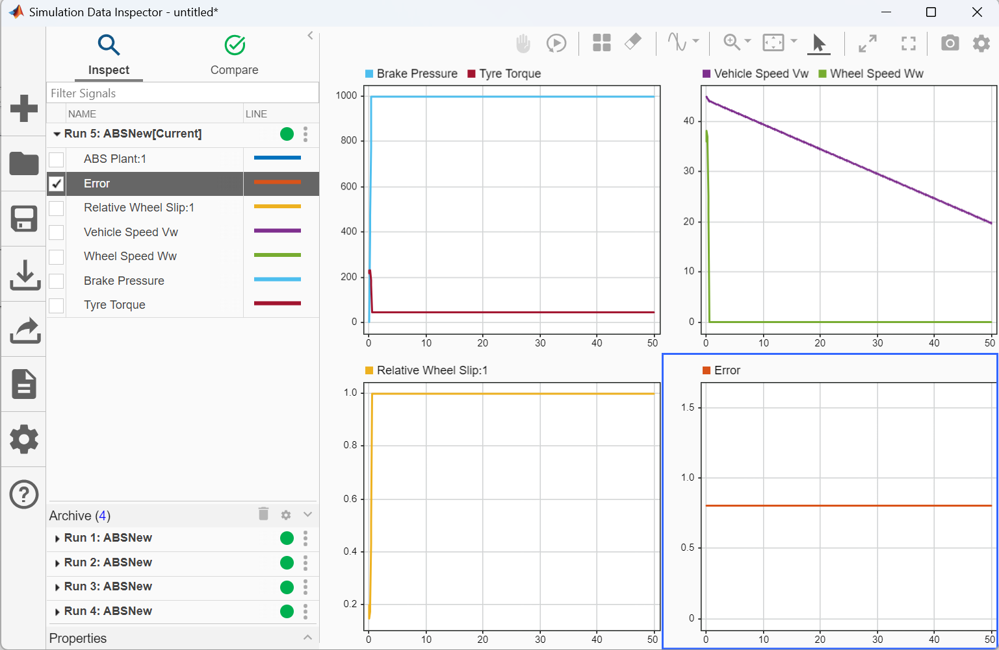
7. Simulation Results - 1. Without ABS
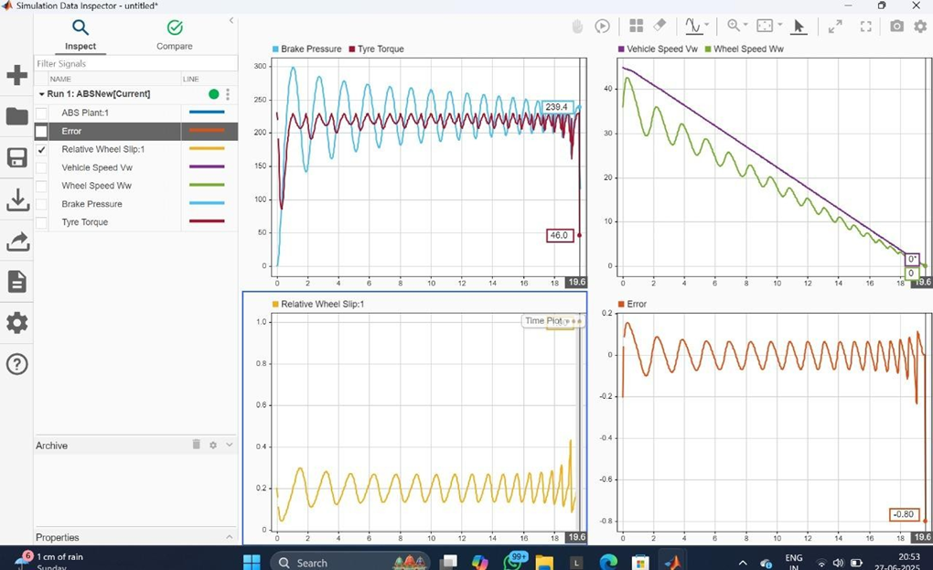
2. With ABS
The simulation results clearly demonstrate the performance improvement achieved by implementing the Anti-Lock Braking System (ABS).
In the Without ABS condition, the wheel experiences rapid lock-up during hard braking, resulting in excessive slip, unstable deceleration, increased stopping distance, and loss of steering control. The braking response becomes highly unstable, especially under low-friction road conditions.
In contrast, the With ABS simulation shows controlled braking behaviour where the PID controller continuously modulates brake pressure to maintain the wheel slip near the optimal range (~0.2). This prevents wheel lock-up and enables stable vehicle deceleration while maintaining tyre-road traction.
- The brake pressure waveform shows continuous modulation of braking force by the PID controller to maintain stable wheel slip.
- The vehicle speed and wheel speed graphs indicate smooth deceleration without wheel lock-up.
- The slip ratio waveform remains close to the desired value (~0.2), ensuring maximum tyre-road traction.
- The slip error graph gradually converges toward zero, indicating effective controller tuning and stable closed-loop operation.
- Oscillations observed in brake pressure represent real ABS behaviour where brake force is rapidly increased and released to prevent skidding.
These results validate the successful implementation of the ABS control strategy.

8. Testing Of model
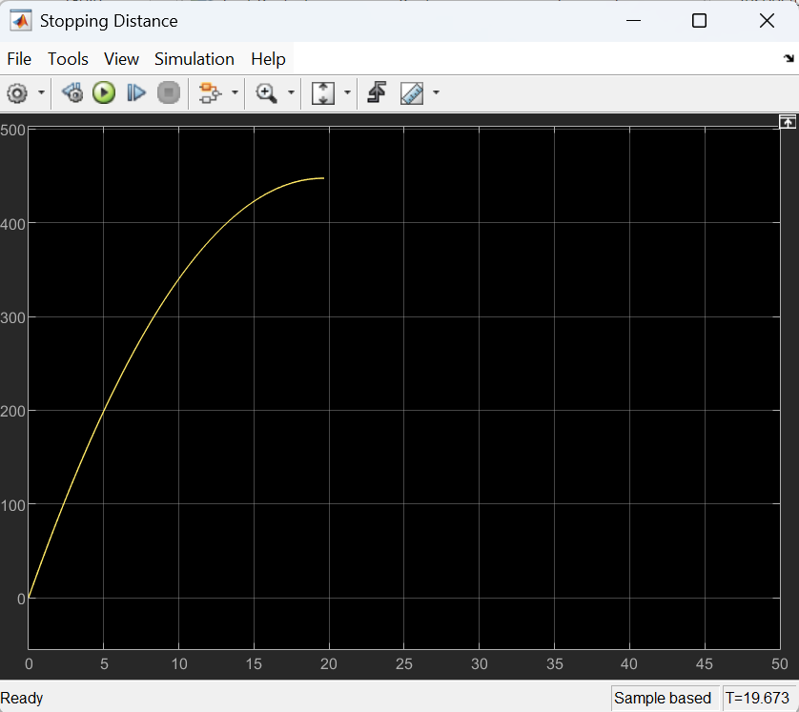
. 1.slip= 0.2
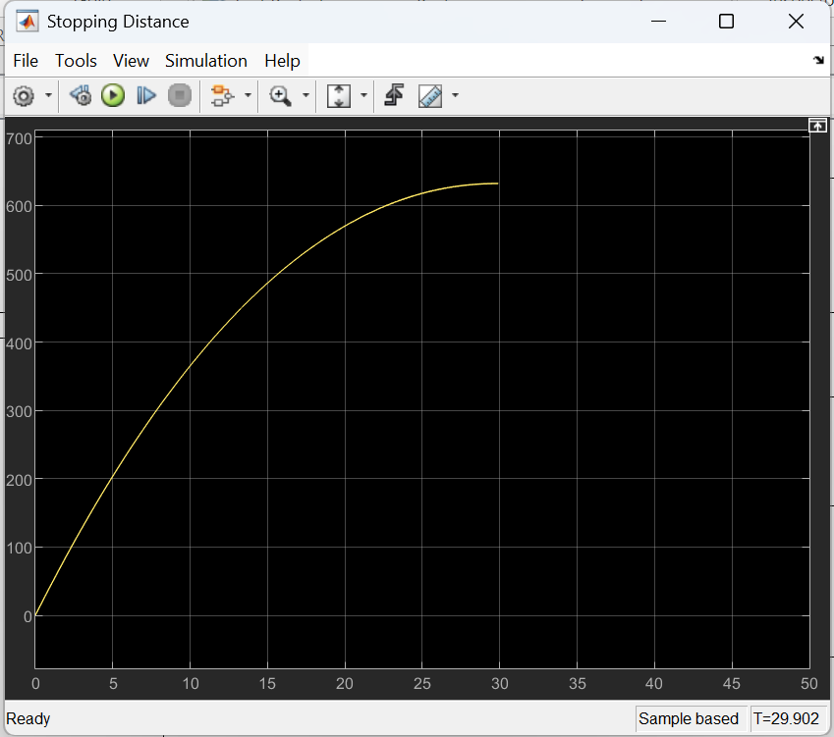
2. slip = 0.4

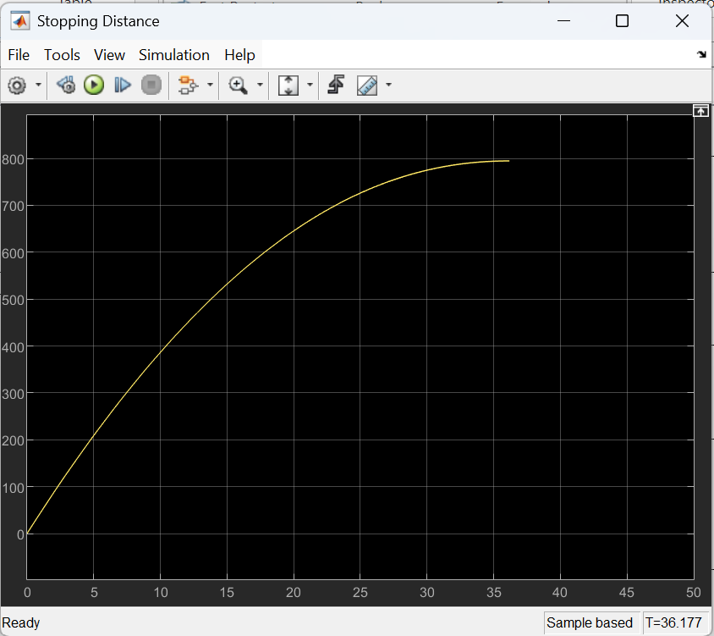
3. Slip = 0.6
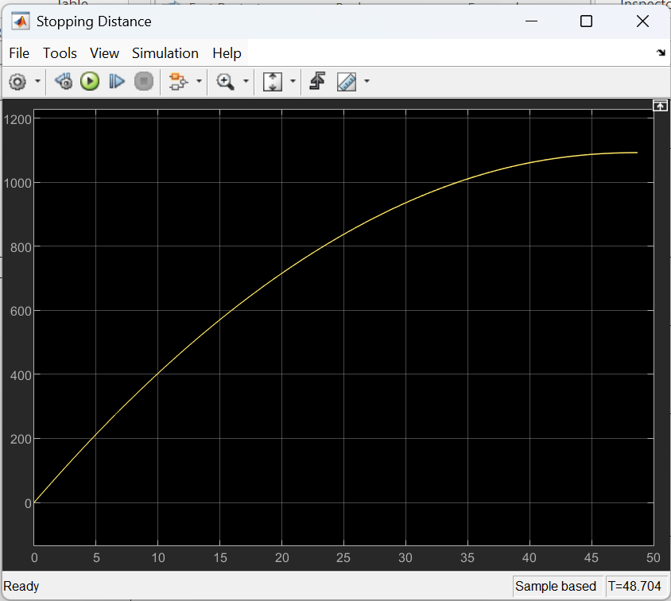
4. Slip = 0.8

From Testing results We can conclude that, Stopping distance of the vehicle is Minimum when wheel slip is kept at 0.2 hence 0.2 is the optimal slip value.

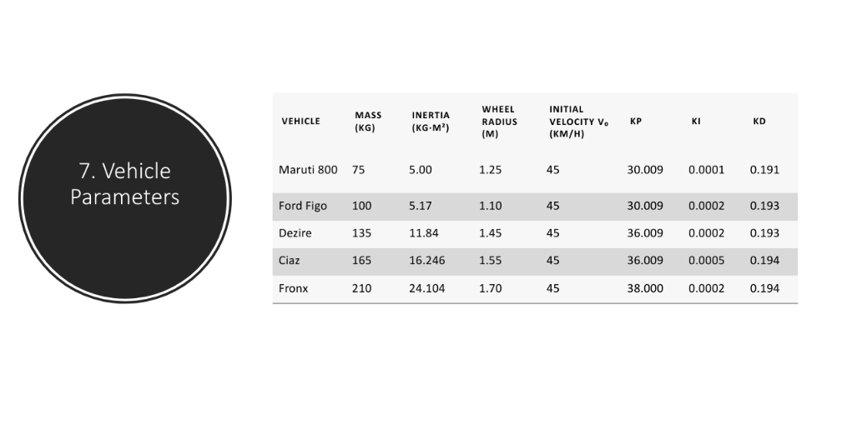
9. Vehicle Parameters Used -
We have Tested an ABS Performance for different vehicles, whose data is shown above.
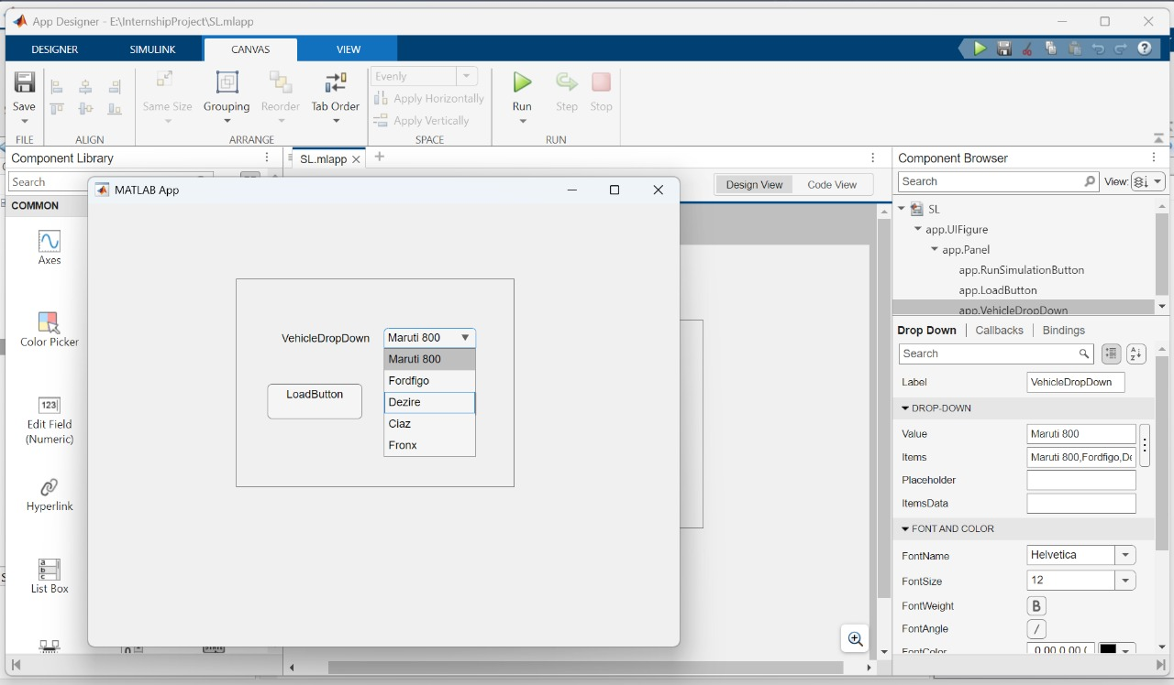
10. GUI

We have crated a graphical user interface by using MATLAB Appdesigner feature. With the help of this GUI whenever User selects Any vehicle from the dropdown menu whose ABS performance is to be checked then parameters of that vehicle will automatically get loaded into the MATLAB Base workspace. And user not need to enter each and every parameter.

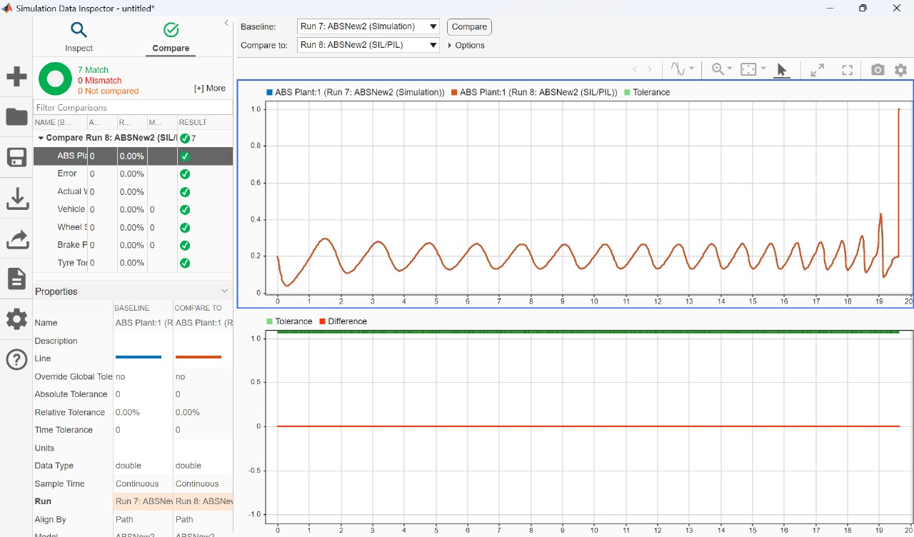
11. Sil Testing Results –
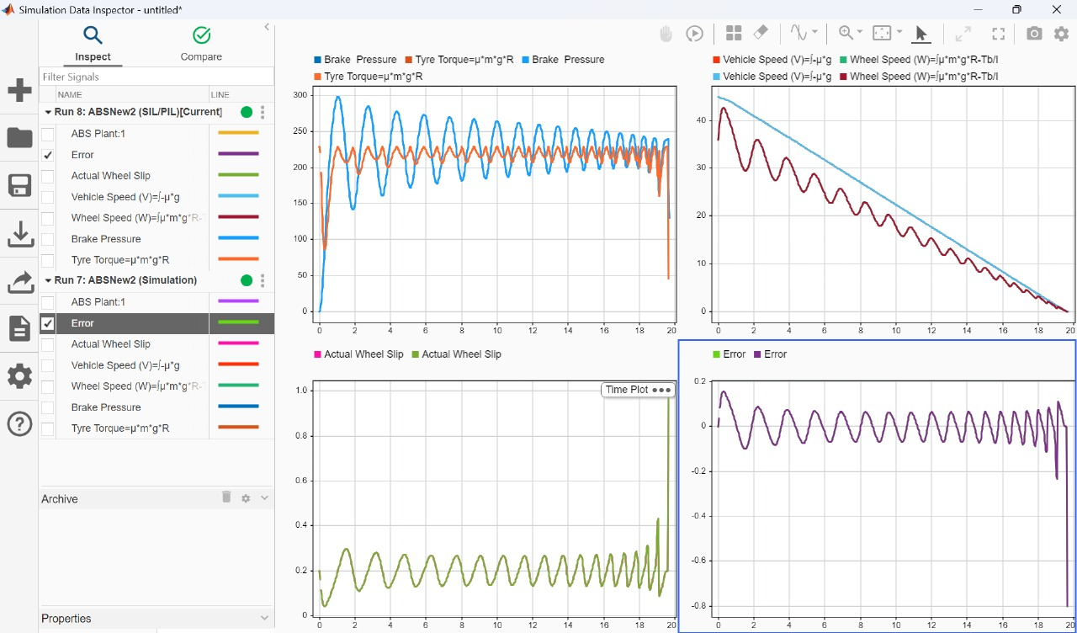

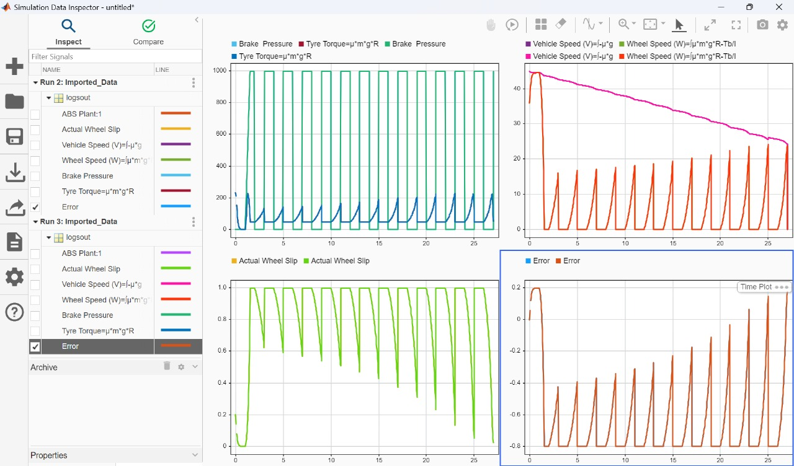
From these results we can conclude that , the results generated from Simulation and code are exactly matching with each other.

12. Auto Generated Code Using Embedded Coder –

13. Conclusion- The project successfully developed a functional ABS system in Simulink with PID-based slip control and SIL validation. The model demonstrated reliable braking behaviour. The proposed hardware architecture is feasible for embedded deployment.
14. References –
1. S. John, “Artificial intelligent-based feedforward optimized PID wheel slip con troller,” in Proc. IEEE As FRICON Conf., 2013.
2. Mohammed Wafi, “Modelling and Simulation of ABS through Different Types of Controllers Using Simulink.

